CSA05-DATABASE MANAGEMENT SYSTEMS
LAB OBSERVATION
EXPERIMENT:09
AIM:

QUESTION:
1. List the departments where the faculty members are working.
SQL QUERIES:
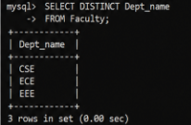
2. Find the student who has no score in any of the courses. List student name and course number.
SQL QUERIES:
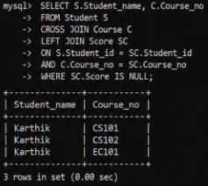
3. The office clerk needs the names of the courses taken by the faculty belonging to ‘ECE department’ whose name is ‘Kamal’
SQL QUERIES:
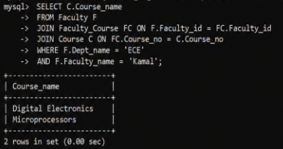
RESULT:
The records from the tables are displayed using JOIN using EquiJoin, InnerJoin, OuterJoin.

